**Project Design Phase-II**

**Data Flow Diagram & User Stories**

|  |  |
| --- | --- |
| Team ID | PNT2022TMID17521 |
| Project Name | Project - Smart Solutions for Railways |
| Maximum Marks | 4 Marks |

**Data Flow Diagrams**

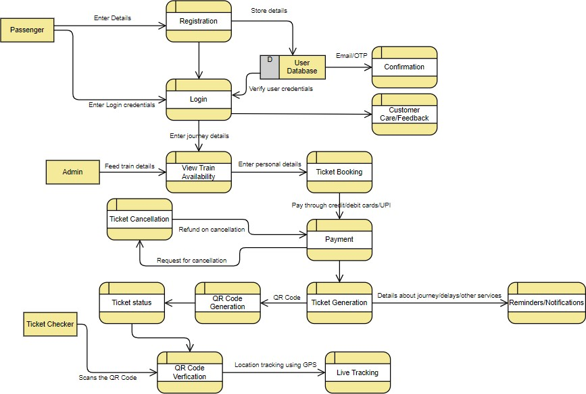

**User Stories**

Use the below template to list all the user stories for the product.

|  |  |  |  |  |  |  |
| --- | --- | --- | --- | --- | --- | --- |
| **User Type** | **Functional**  **Requirement (Epic)** | **User**  **Story**  **Number** | **User Story / Task** | **Acceptance criteria** | **Priority** | **Release** |
| Customer  (Mobile user,  Web user) | Registration | USN-1 | As a user, I can register through the form by filling in my details. | I can register and create my account /dashboard | High | Sprint-1 |
|  |  | USN-2 | As a user, I can register through phone numbers, gmail, facebook or other social sites. | I can register & create my dashboard with Facebook  Login or other social sites | High | Sprint-2 |
|  | Confirmation | USN-3 | As a user, I will receive confirmation through email or OTP once registration is successful. | I can receive confirmation email & click confirm | High | Sprint-1 |
|  | Authentication/Login | USN-4 | As a user, I can login via login ID and password or through OTP received on registered phone number. | I can login and access my account/dashboard | High | Sprint-1 |
|  | Display train details | USN-5 | As a user, I can enter the start and destination to get the list of trains available connecting the above. | I can view the train details(name & number), corresponding routes it passes through based on the start and destination entered. | High | Sprint-1 |
|  | Booking | USN-6 | As a user, I can provide the basic details such as name, age, gender etc. | I can view,modify or confirm the details entered. | High | Sprint-1 |
|  |  | USN-7 | As a user, I can choose the class, seat/berth. If a preferred seat/berth isn’t available I can be allotted based on the availability. | I can view, modify or confirm the  seats/class/berth selected | High | Sprint-1 |
|  | Payment | USN-8 | As a user, I can choose to pay through credit card/debit card/UPI. | I can view the payment options available and select my desirable choice to proceed with the payment. | High | Sprint-1 |
|  |  | USN-9 | As a user, I will be redirected to the selected payment gateway and upon successful completion of payment I’ll be redirected to the booking website. | I can pay through the payment portal and confirm the booking.If any changes need to be done I can move back to the initial payment page. | High | Sprint-1 |
| **User Type** | **Functional**  **Requirement (Epic)** | **User**  **Story**  **Number** | **User Story / Task** | **Acceptance criteria** | **Priority** | **Release** |
|  | Ticket generation | USN-10 | As a user, I can download the generated e-ticket for my journey along with the QR code which is used for authentication during my journey. | I can show the generated QR code so that authentication can be done quickly. | High | Sprint-1 |
|  | Ticket status | USN-11 | As a user, I can see the status of my ticket whether it’s confirmed/waiting/RAC. | I can constantly get the information and arrange alternate transport if the ticket isn’t confirmed. | High | Sprint-1 |
|  | Reminders/Notification | USN-12 | As a user, I get reminders about my journey a day before my actual journey. | I can make sure that I don’t miss the journey because of the constant notifications. | Medium | Sprint-2 |
|  |  | USN-13 | As a user, I can track the train using GPS and can get information such as ETA, current stop and delays. | I can track the train and get to know about the delays and plan accordingly. | Medium | Sprint-2 |
|  | Ticket cancellation | USN-14 | As a user, I can cancel my ticket if there’s any change of plan. | I can cancel the ticket and get a refund based on how close the date is to the commencement of the journey. | High | Sprint-1 |
|  | Raise queries | USN-15 | As a user, I can raise queries through the query box or via mail. | I can view my previous queries. | Low | Sprint-2 |
| Customer Care Executive | Answer the queries | USN-16 | As a user, I will answer the queries/doubts raised by the customers. | I can view the queries and mark it once resolved. | Medium | Sprint-2 |
| Administrator | Feed details | USN-17 | As a user, I will feed information about the trains, delays and add extra seats if a new compartment is added. | I can view and ensure the correctness of the information fed. | High | Sprint-1 |